# **Assignment 2**

# **Image Arithmetic, Histogram Equalization, Drawing Application, Geometric Transformation, Noise & Filtering**

## **Part I: Image Arithmetic & Histogram Equalization**

Create a program (save as Assignment2_1). Include code to:

1. Brightness & Contrast:
2. Open a color image and display. Paste a sample here.

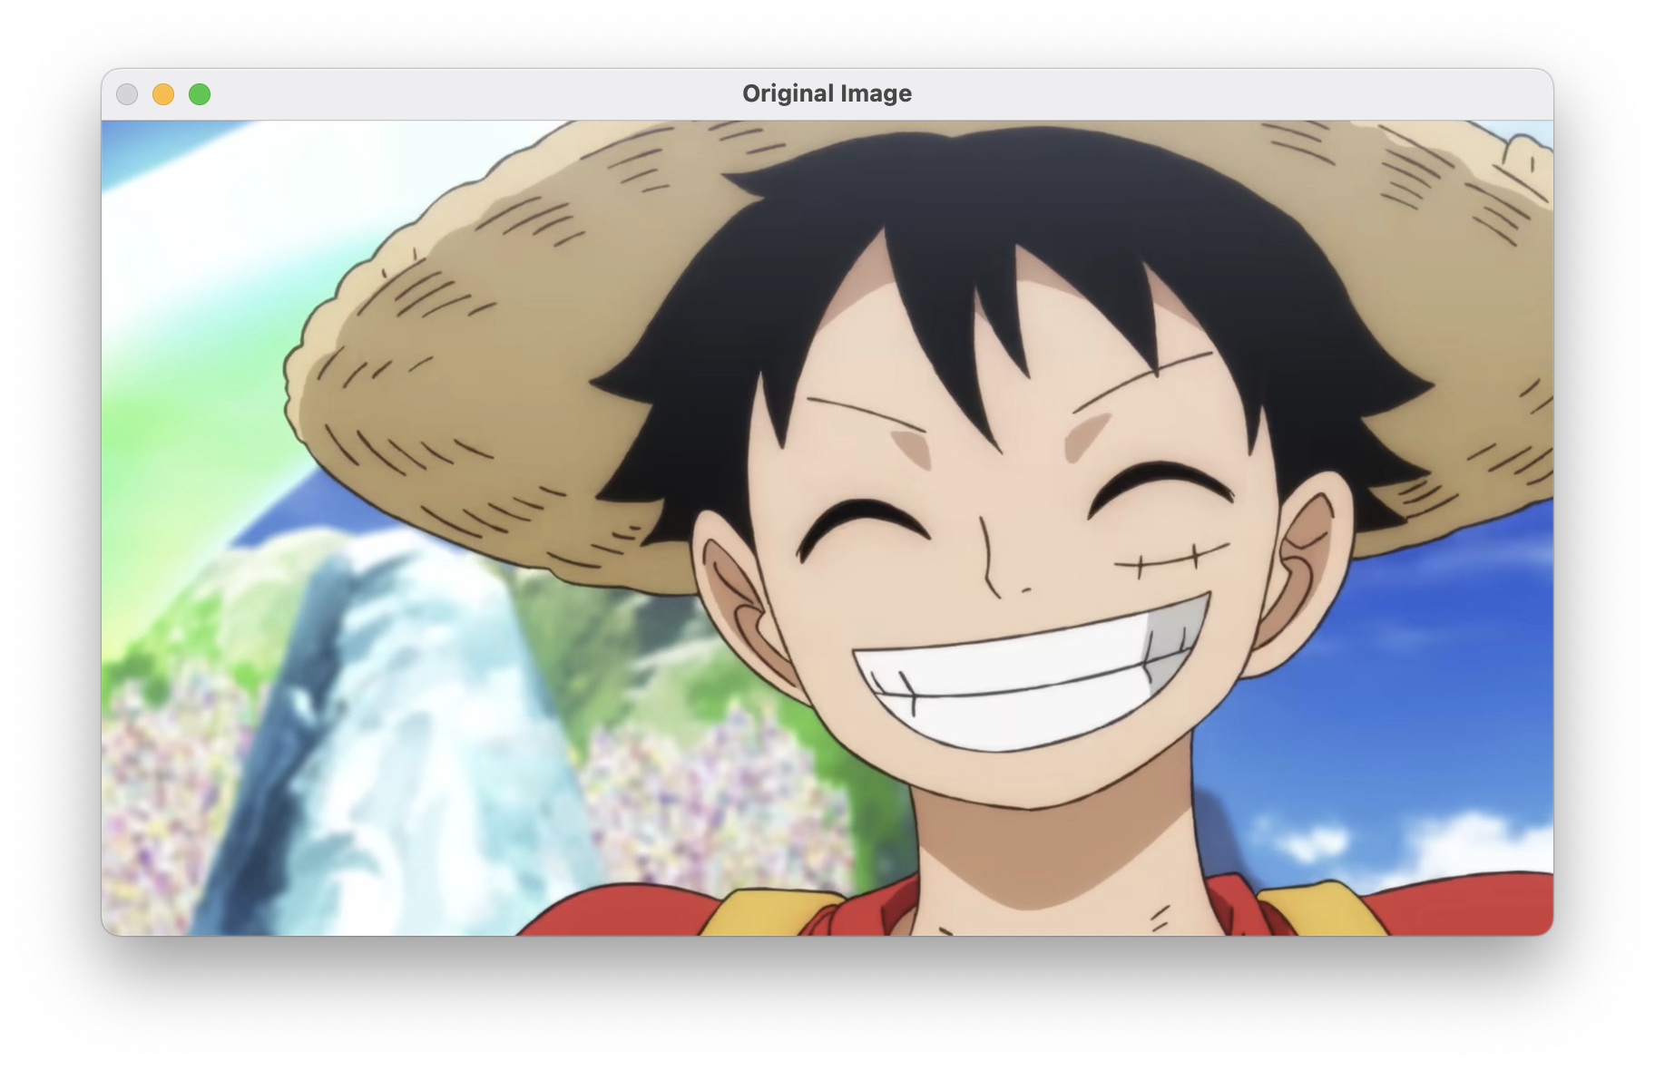

1. Change the brightness by a constant (e.g., 100). Display in a separate window. Paste the result here.

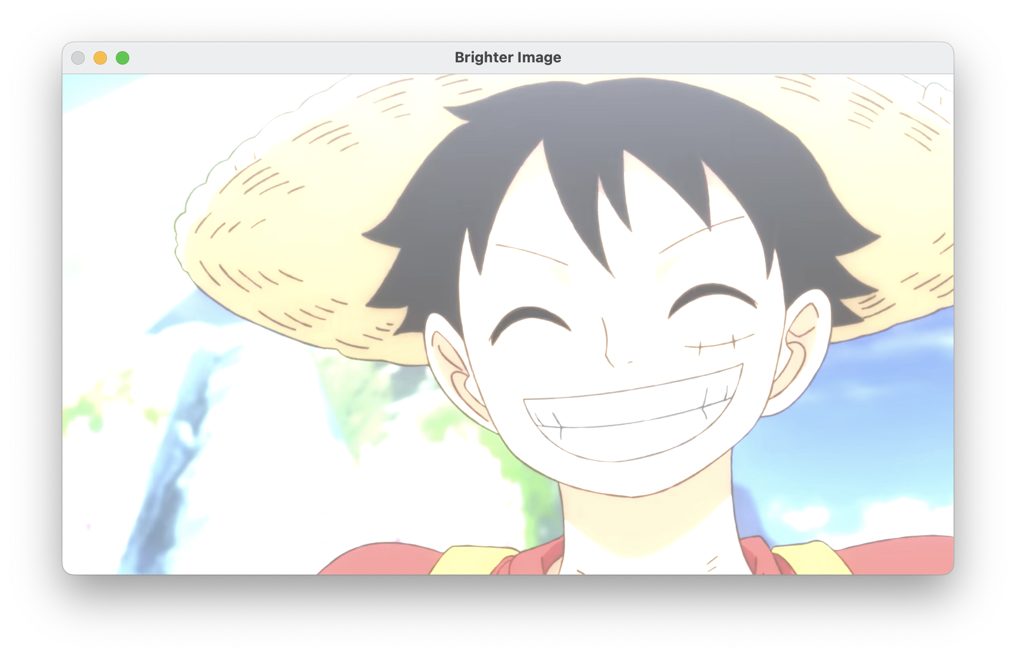

1. Change the contrast by a constant (e.g., 0.5, 2). Display in a separate window. Paste the result here.

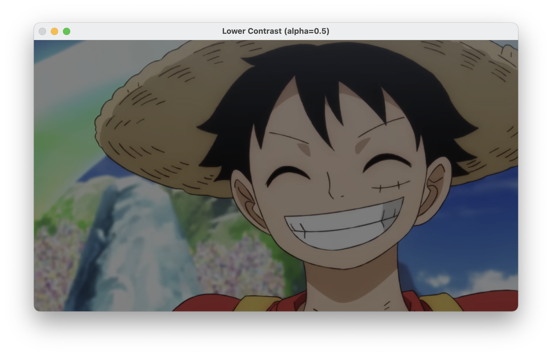

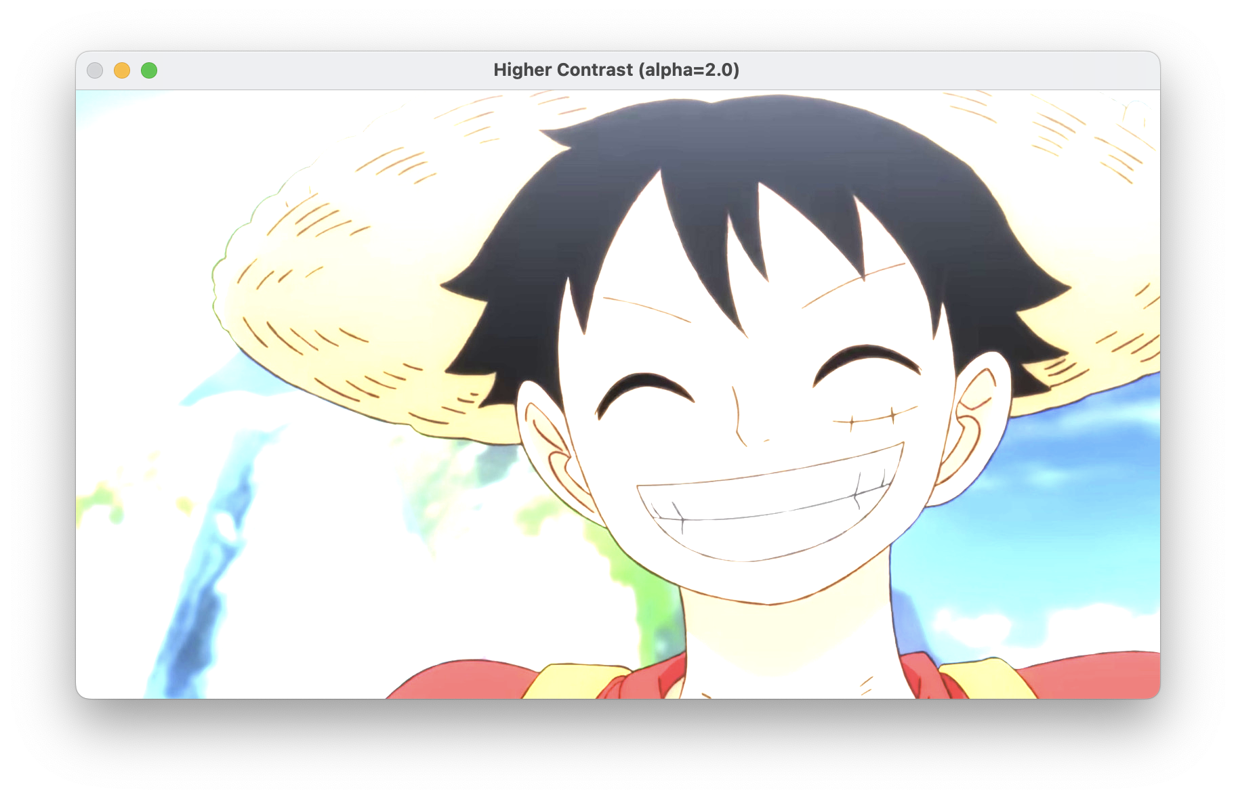

1. Linear blend:
2. Open a second images and display. Resize the second image to match the first, if needed. Paste a sample here.

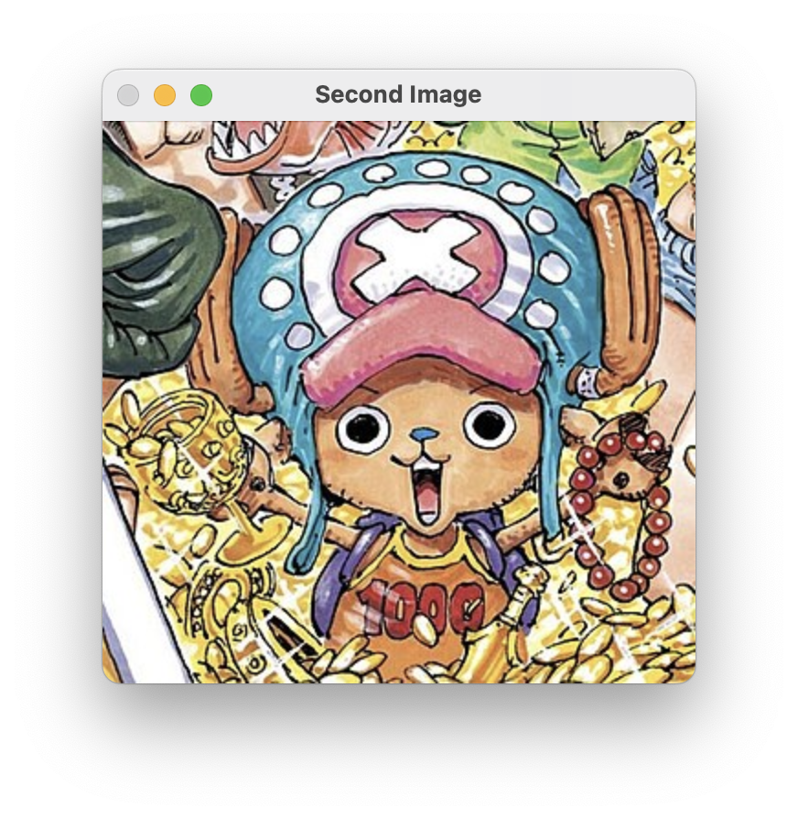

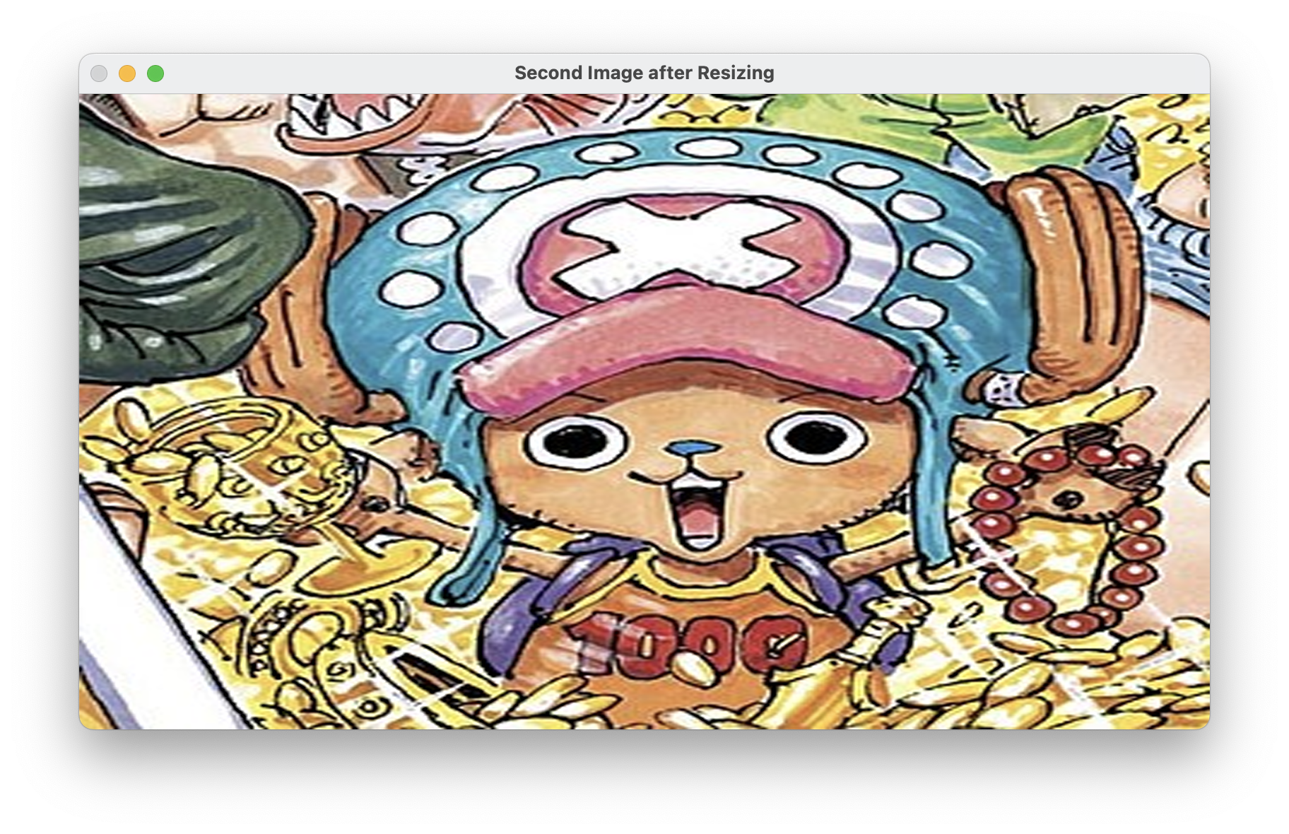

1. Implement a linear blend of the two images: create a for loop to linearly blend these images, progressively varying the blending ratio (alpha) throughout the loop.
$blend = (1 - alpha) * img1 + alpha * img2;$

2. Paste the blended images at different stages of blending (at alpha = 0.2, alpha = 0.5, and alpha = 0.8).

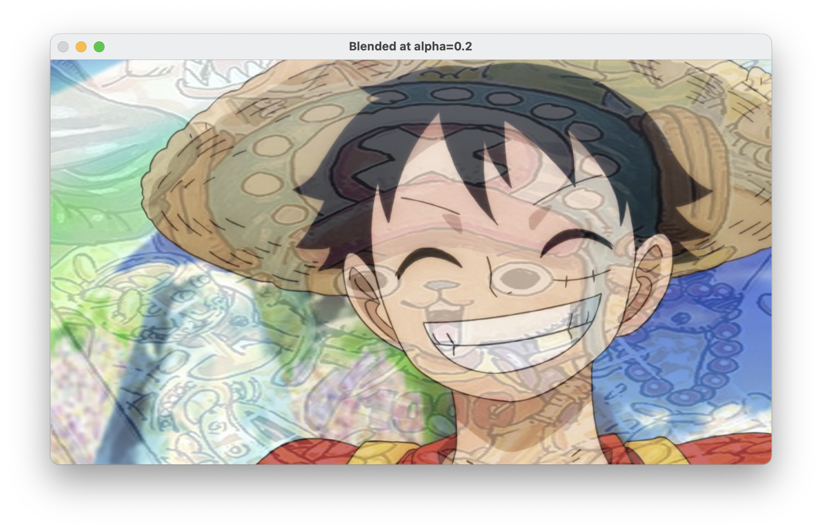

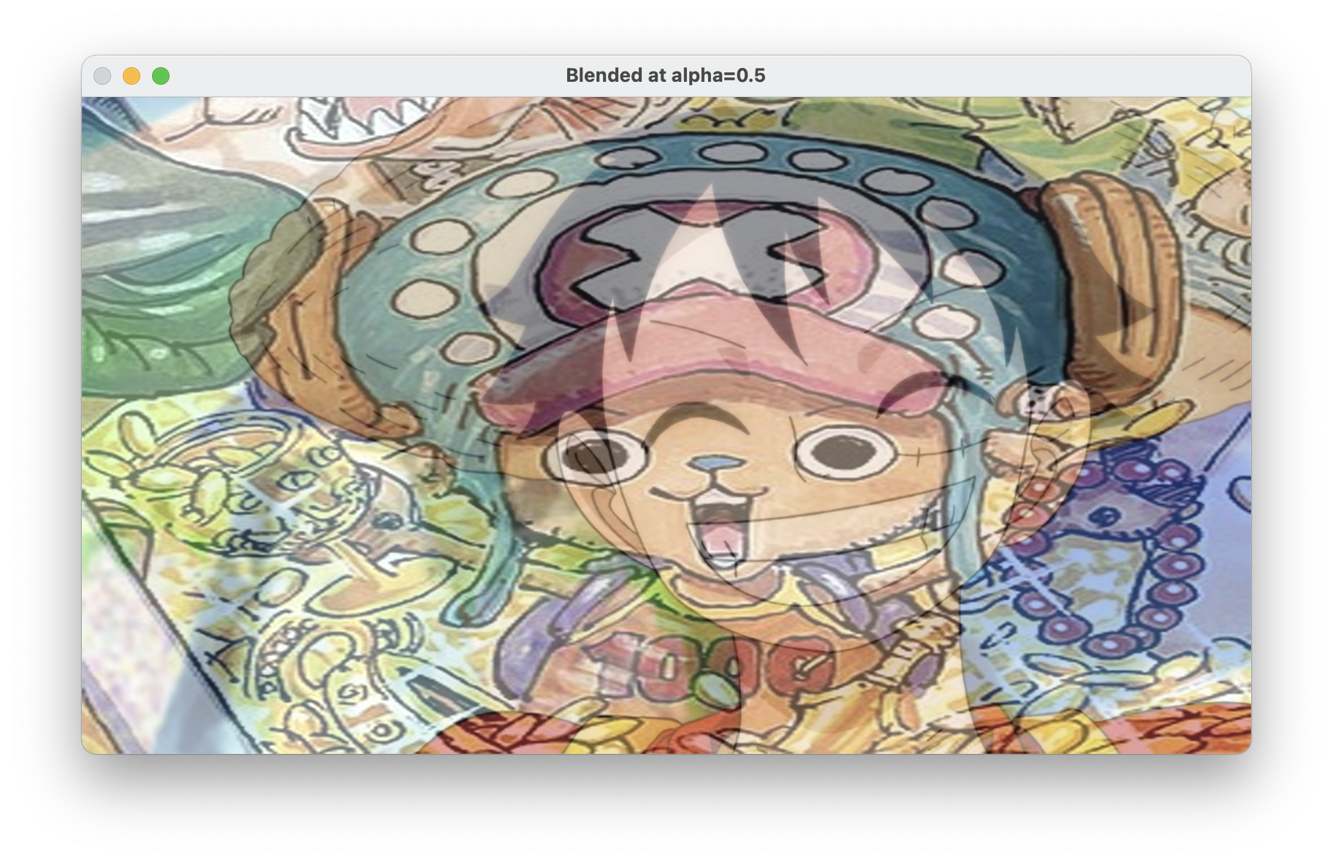

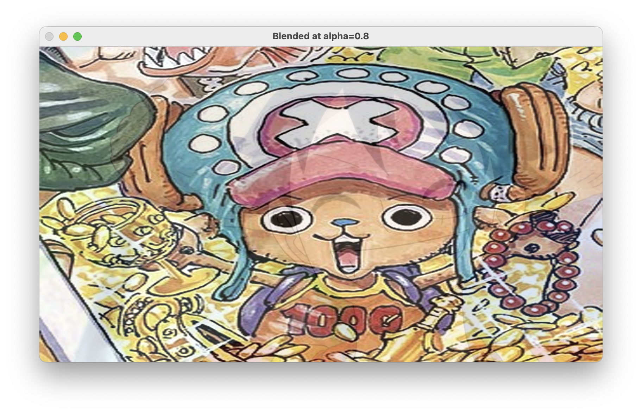

1. (Optional) Save the blended images to a file, create a GIF animation, and submit it with the assignment.
2. Histogram Equalization
3. Open ‘nail_polish’ and apply histogram equalization to it. To do so, convert the image to HSV color space, apply histogram equalization once on the ‘saturation’ channel and once on the ‘value’ channel. Hint: [Image Histograms in OpenCV Python | Image Processing | coseries](https://coseries.com/image-histograms-in-opencv-python/#:~:text=Image%20Histograms%20in%20OpenCV%20Python%20In%20image%20processing%2C,representation%20of%20the%20intensity%20distribution%20of%20an%20image.)
4. Show (1) the equalized images and (2) the changes to the histograms.

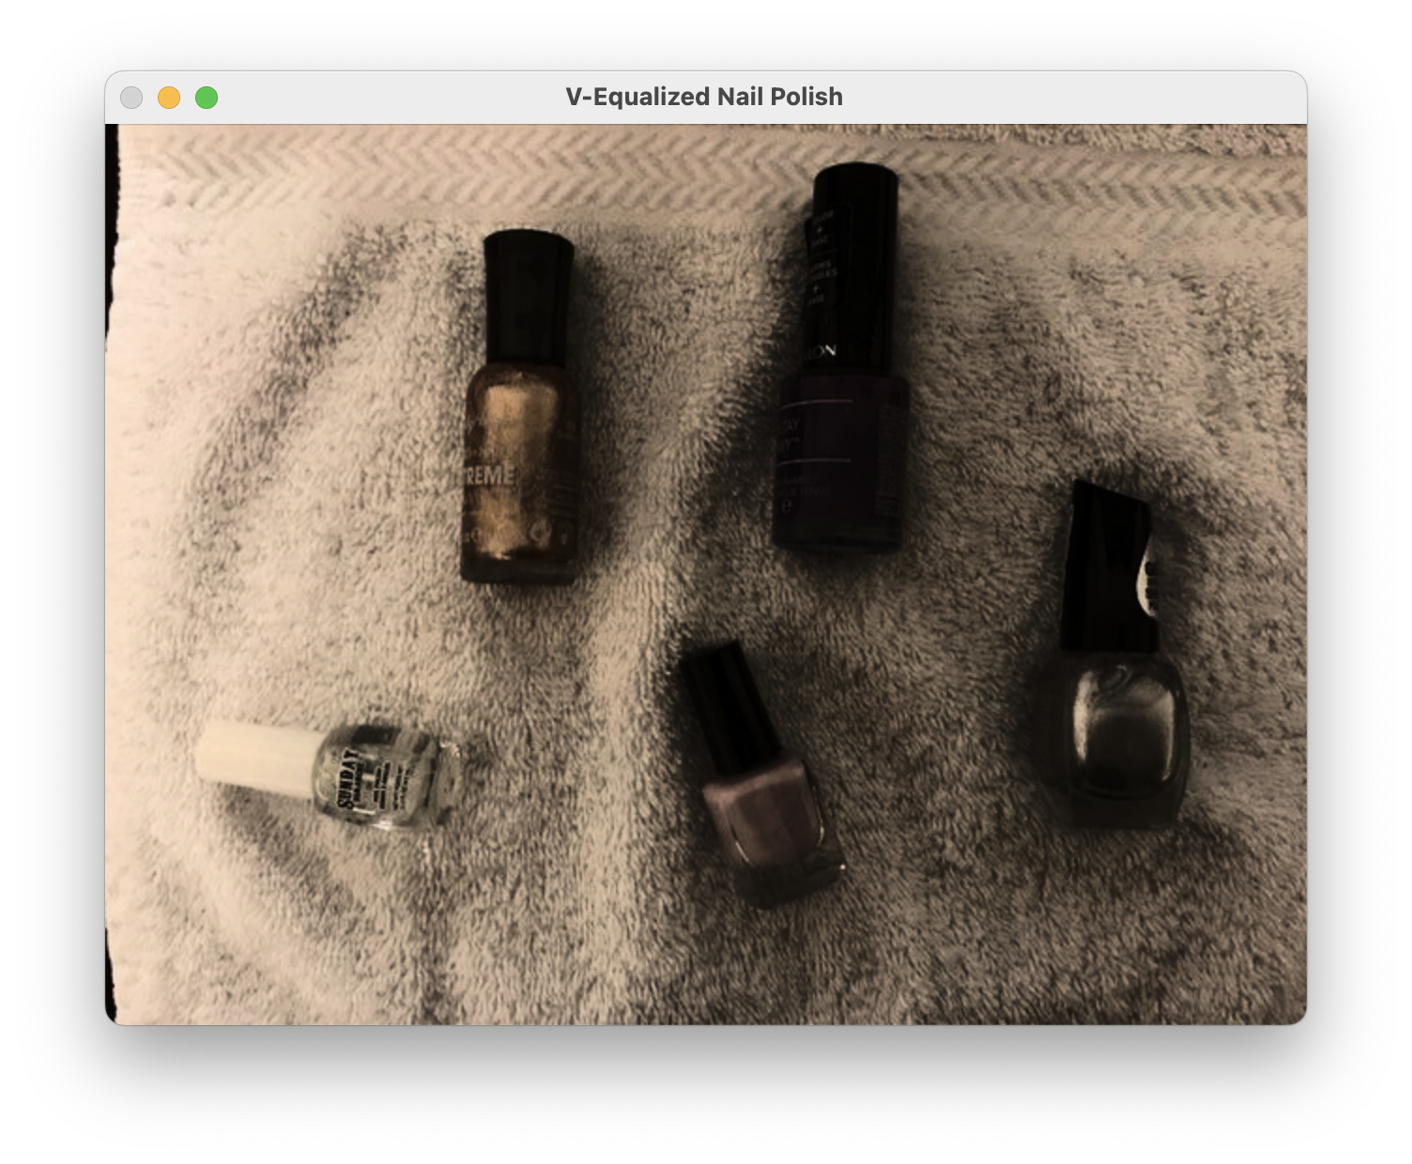

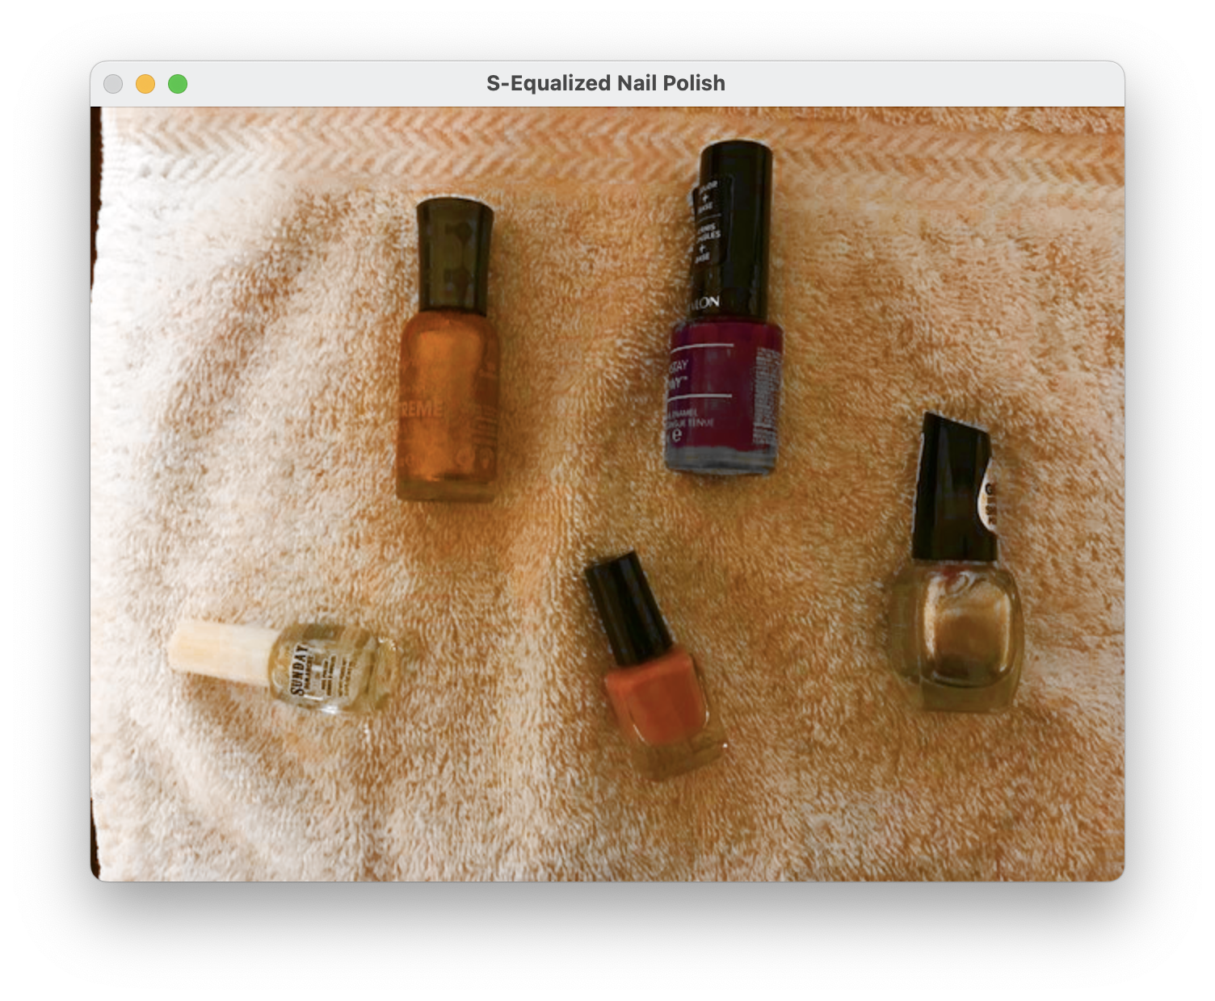

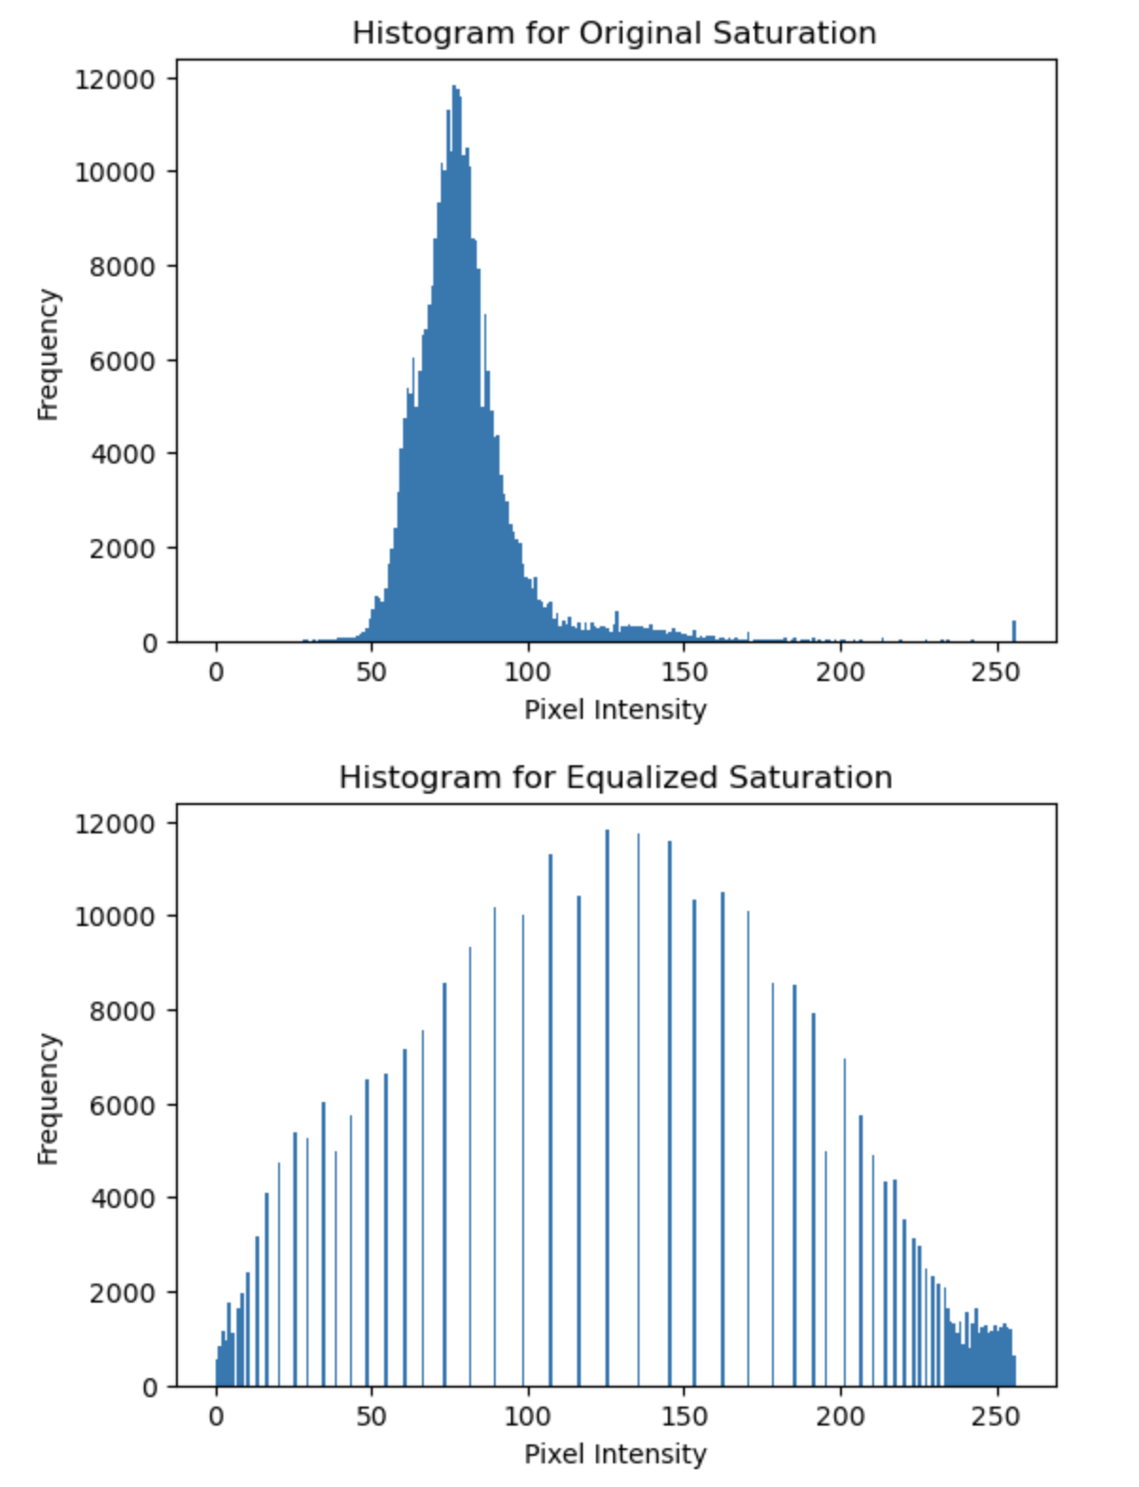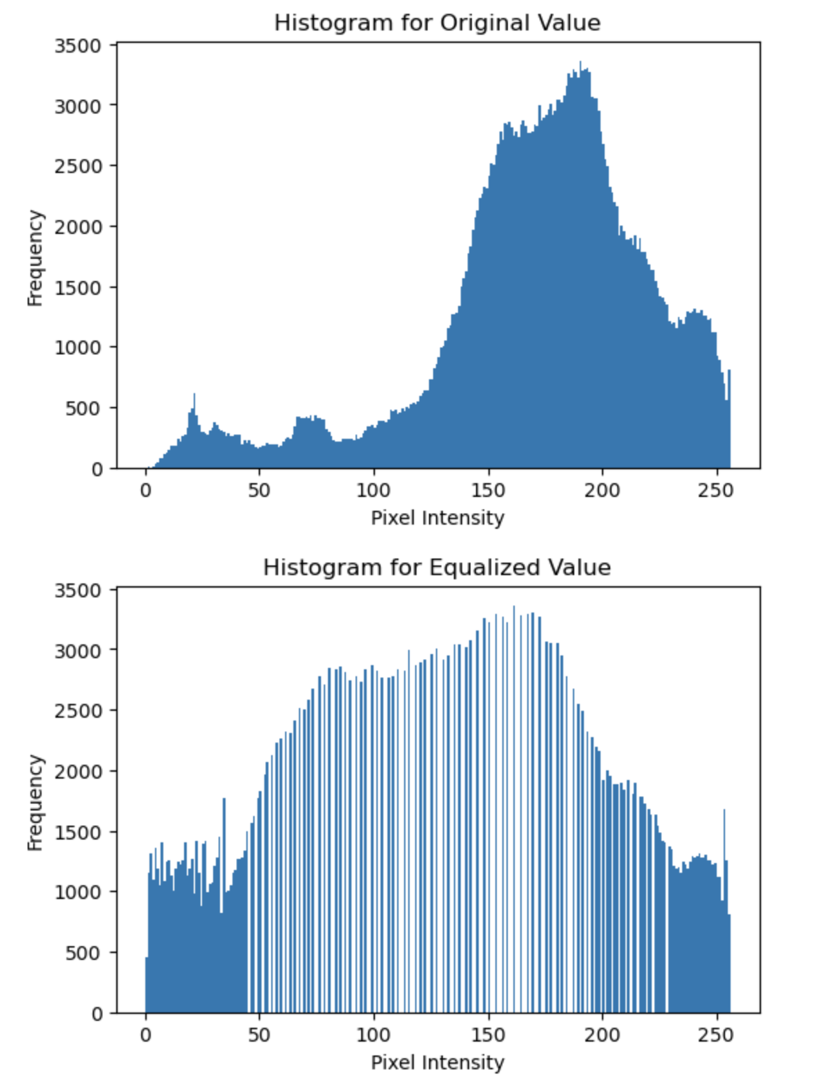

## **Part II: Drawing Application**

Create a program (save as Assignment2_2).

1. Include code from [OpenCV: Mouse as a Paint-Brush](https://docs.opencv.org/4.10.0/db/d5b/tutorial_py_mouse_handling.html) ‘More Advanced Demo’. Modify the program to draw rectangles or small circles with your desired colors. Paste a sample here.

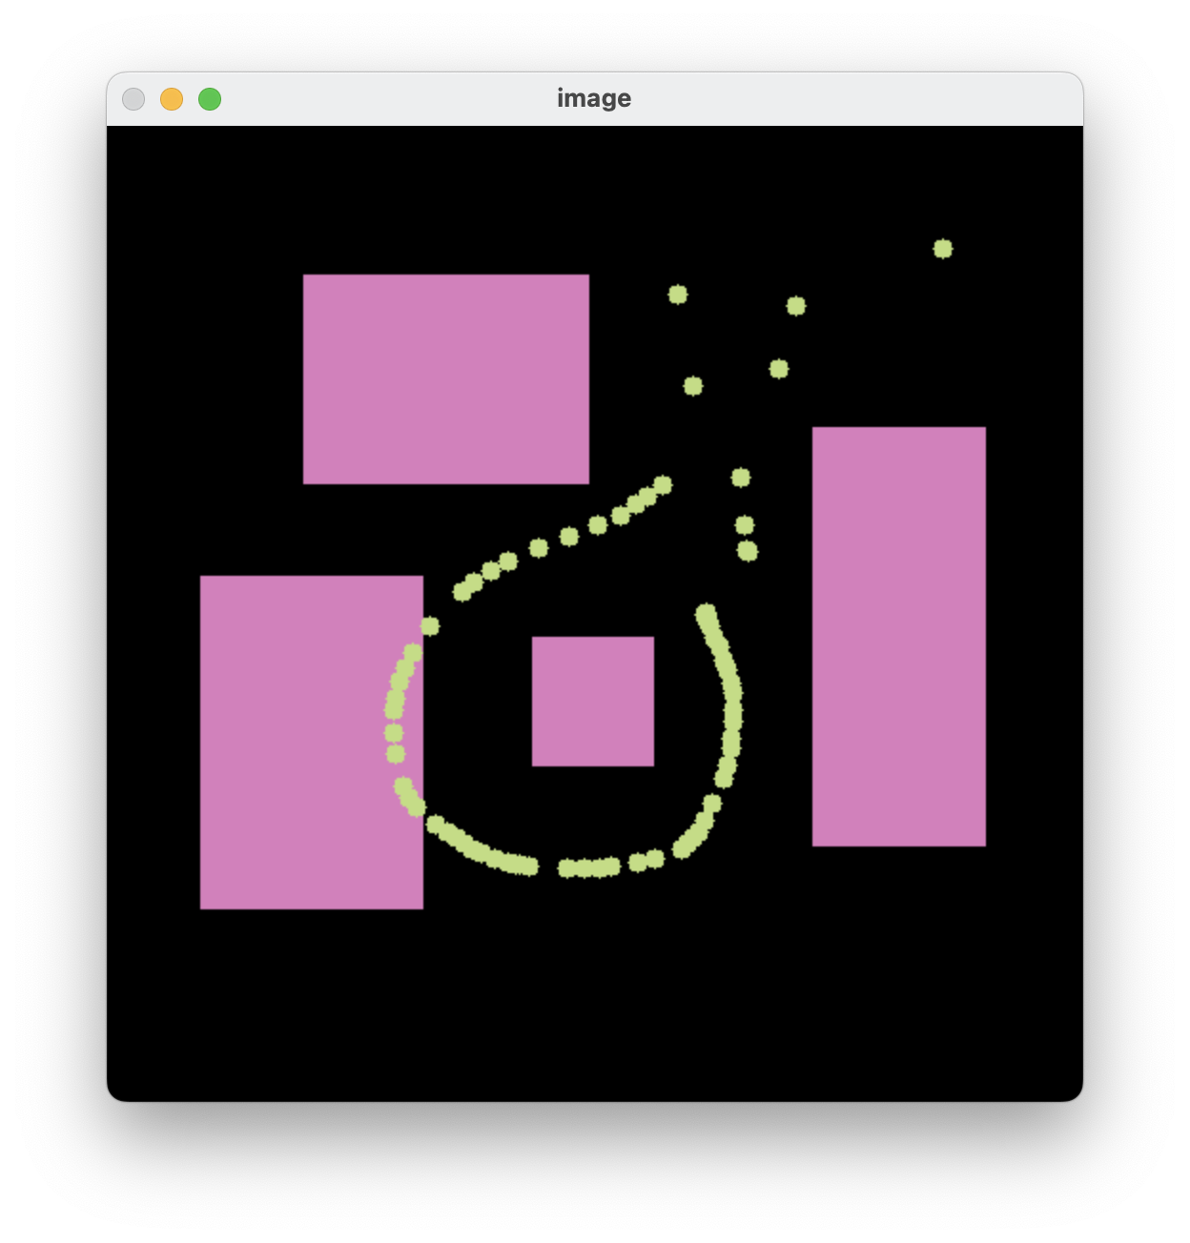

1. Lower the refresh rate, remove the (-1) flag from the shape functions and change thickness. What do you notice? Explain. Paste a sample here.
2. Lowering the refresh rate with time.sleep(0.03) introduces a slight lag before each frame is shown.
3. Removing the -1 flag and replacing it with a positive integer for thickness results in shapes not being filled. Instead of a filled rectangle or circle, we can see an outline only.
4. Previously we had -1, so the shape would fill instantly, which means at a high refresh rate, we are not able to see the shape being drawn step by step. With a slower refresh rate and a non-filled shape, we get more of a sense of the drawing happening in steps.

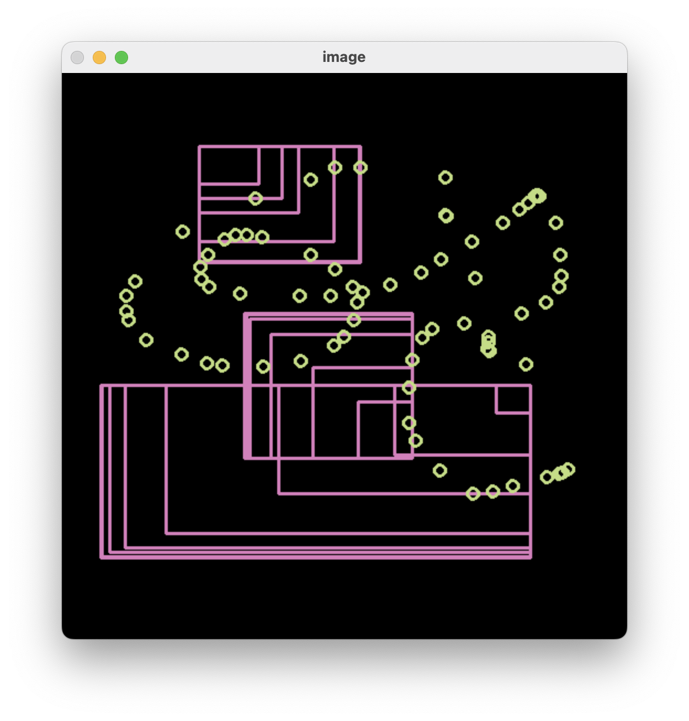

1. (Optional) Change the code to do the followings:
2. Load a new image (or use a black image). Once draw **polylines** and once draw **polygons** with your desired colors. Hint: [Draw on Images using Mouse in OpenCV Python - ML Hive](https://mlhive.com/2022/04/draw-on-images-using-mouse-in-opencv-python)
3. Save images when ‘x’ is pressed. Paste a sample here.

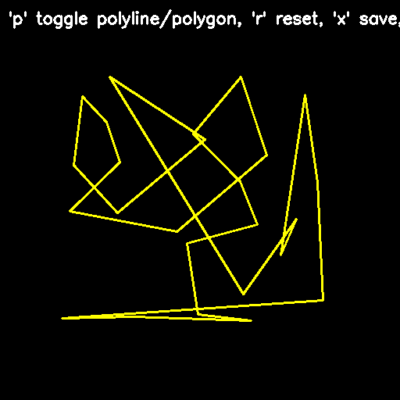

## **Part III: Geometric Transformation**

Create a program (save as Assignment02_3). Include code to:

1. Open a color image and display. Paste a sample here.

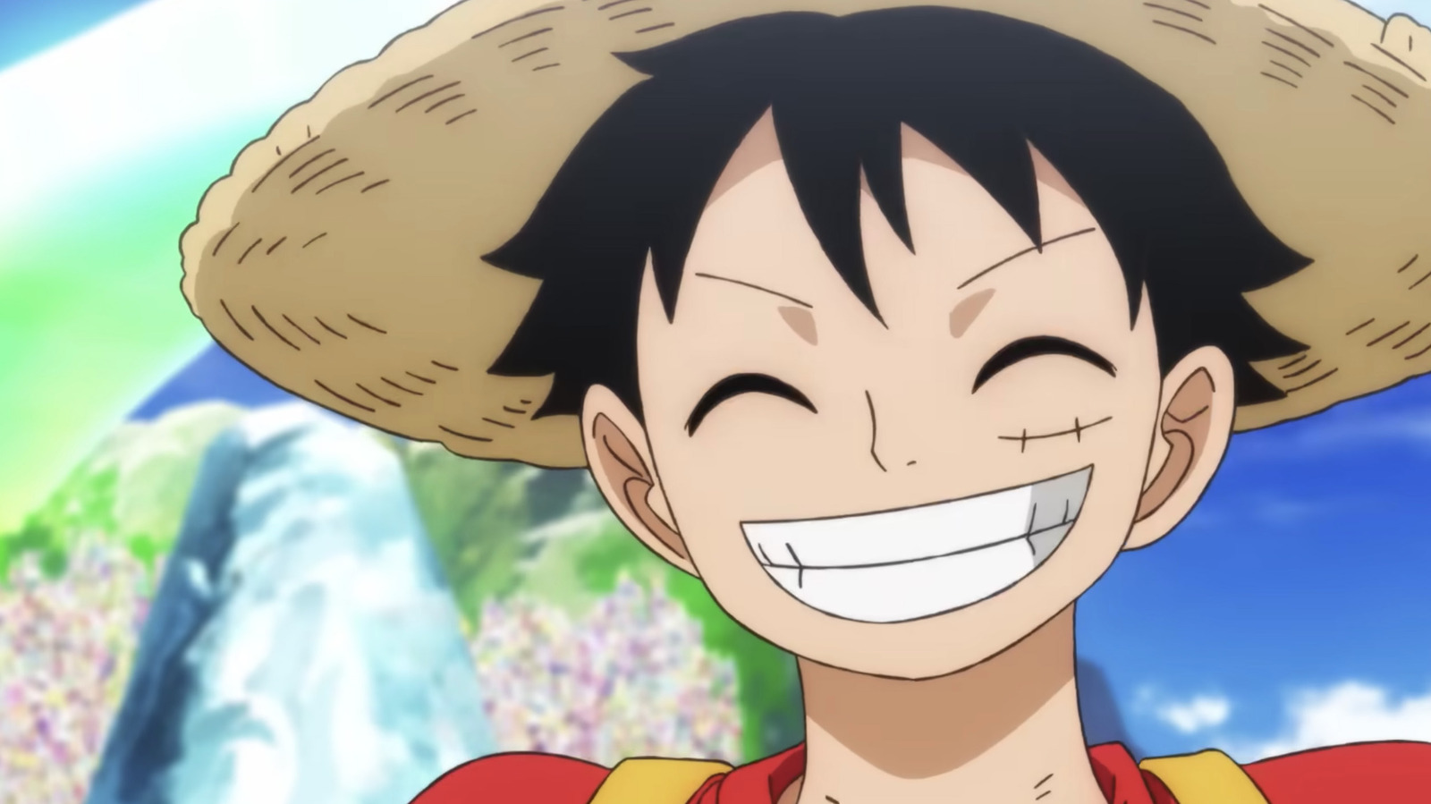

1. In a loop, ask the user whether they want to rotate, resize, apply perspective transformation, or exit.

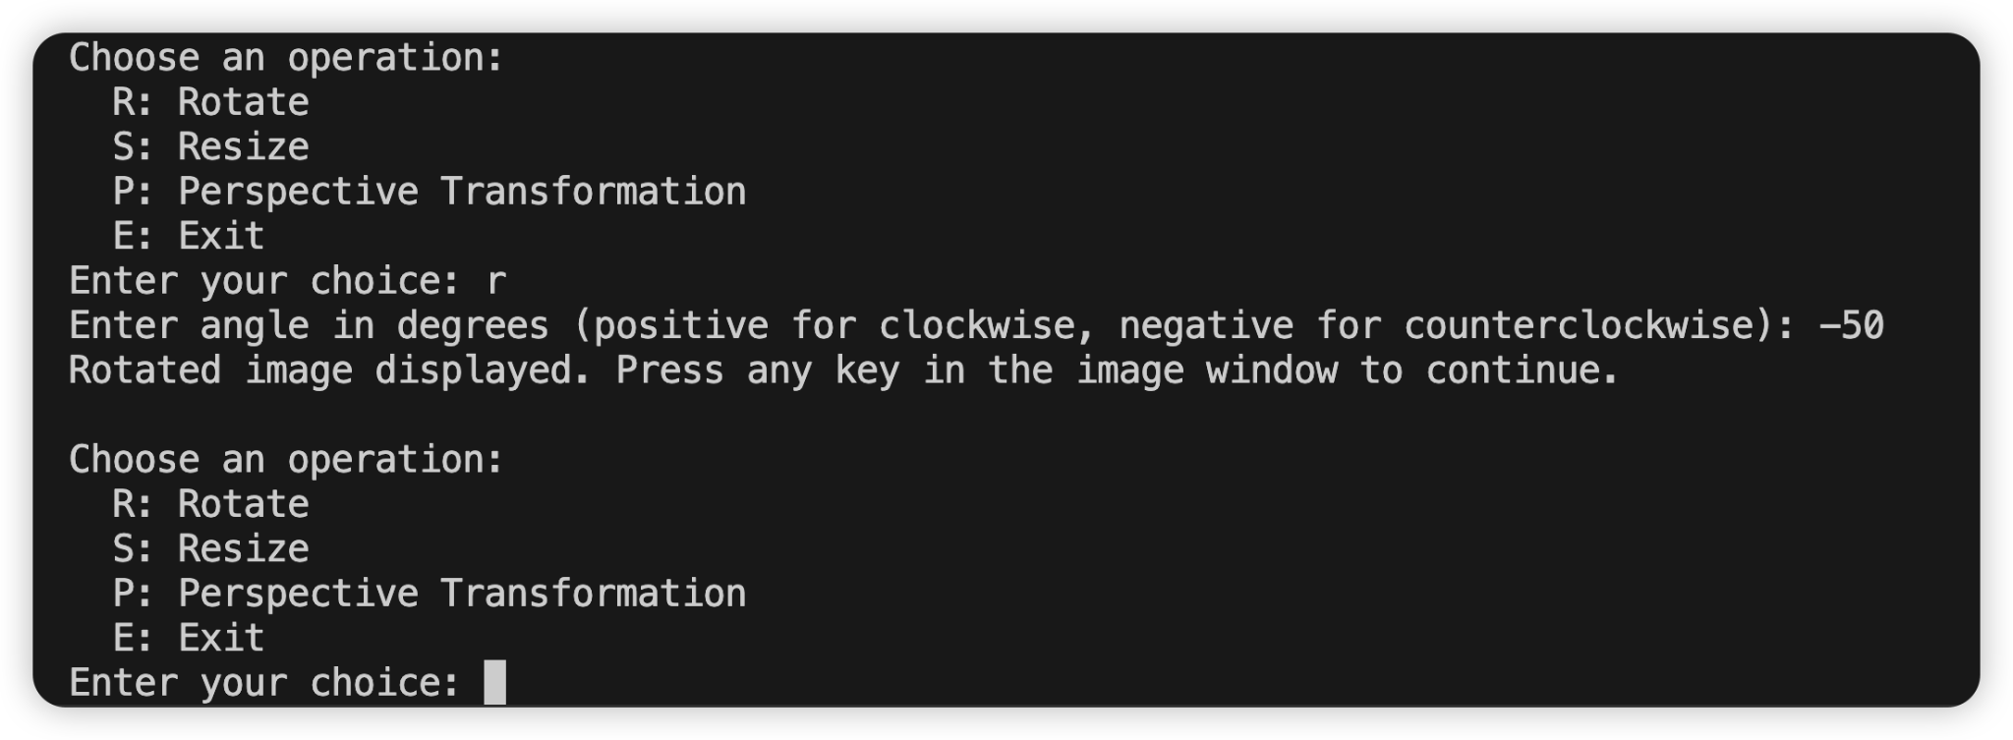

1. If **rotation** is selected, ask for an angle (in degrees). Then rotate the image around the center of the image with the given angle and displays the rotated image. Run the code with:
2. Rotate for 25 degrees clockwise. Paste the sample here.

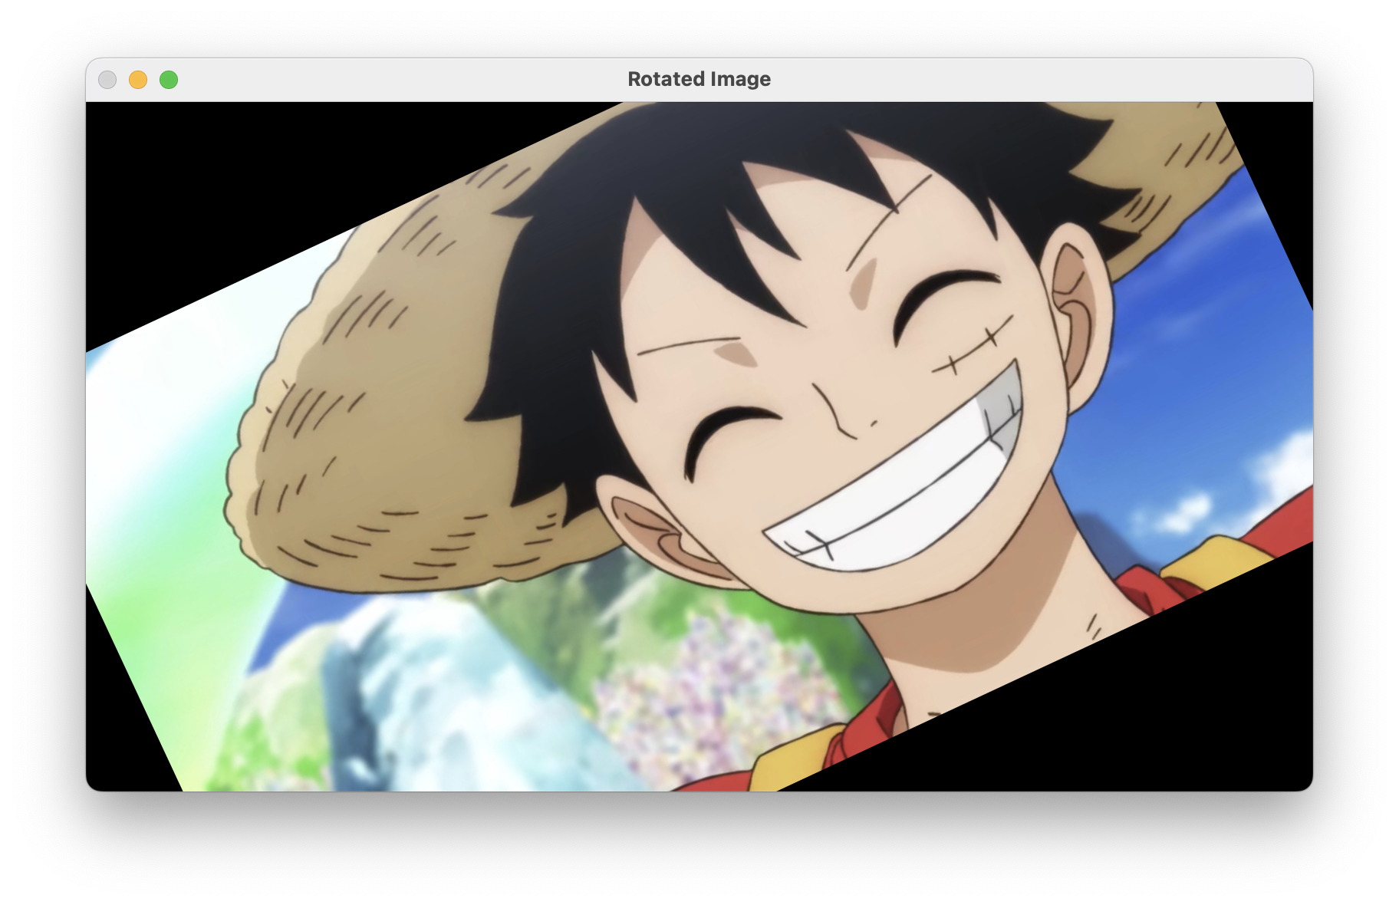

1. Rotate for 50 degrees counterclockwise. Paste the sample here.

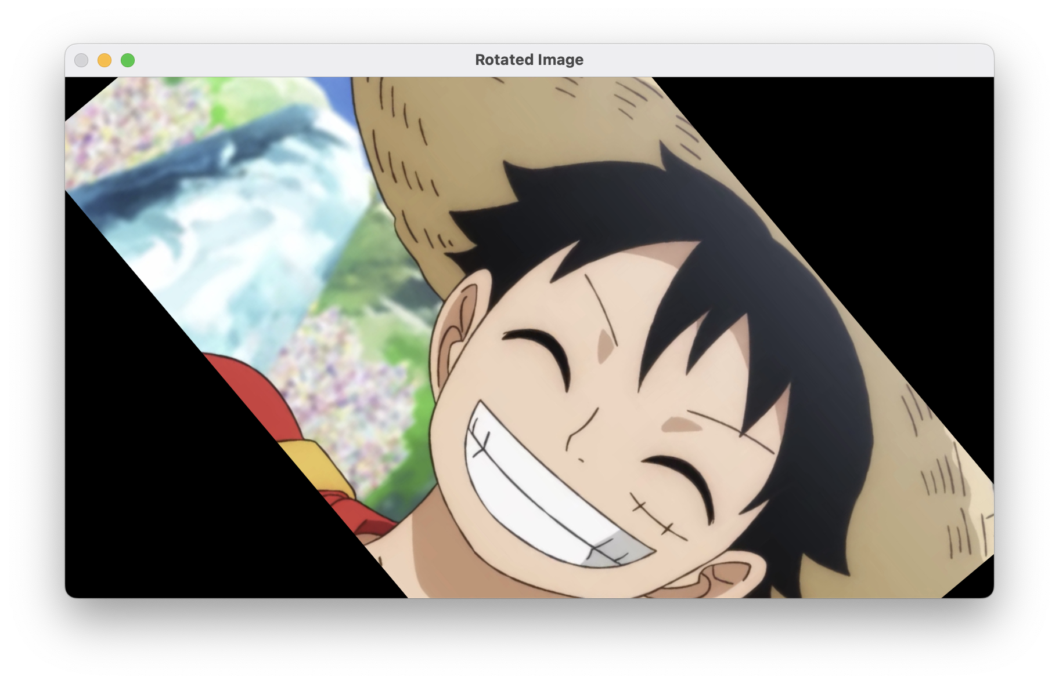

1. If **resizing** is selected, ask for the resizing factors along each axis and resize the image. Run the code resizing the image to double the width and half the height. Paste the sample here.

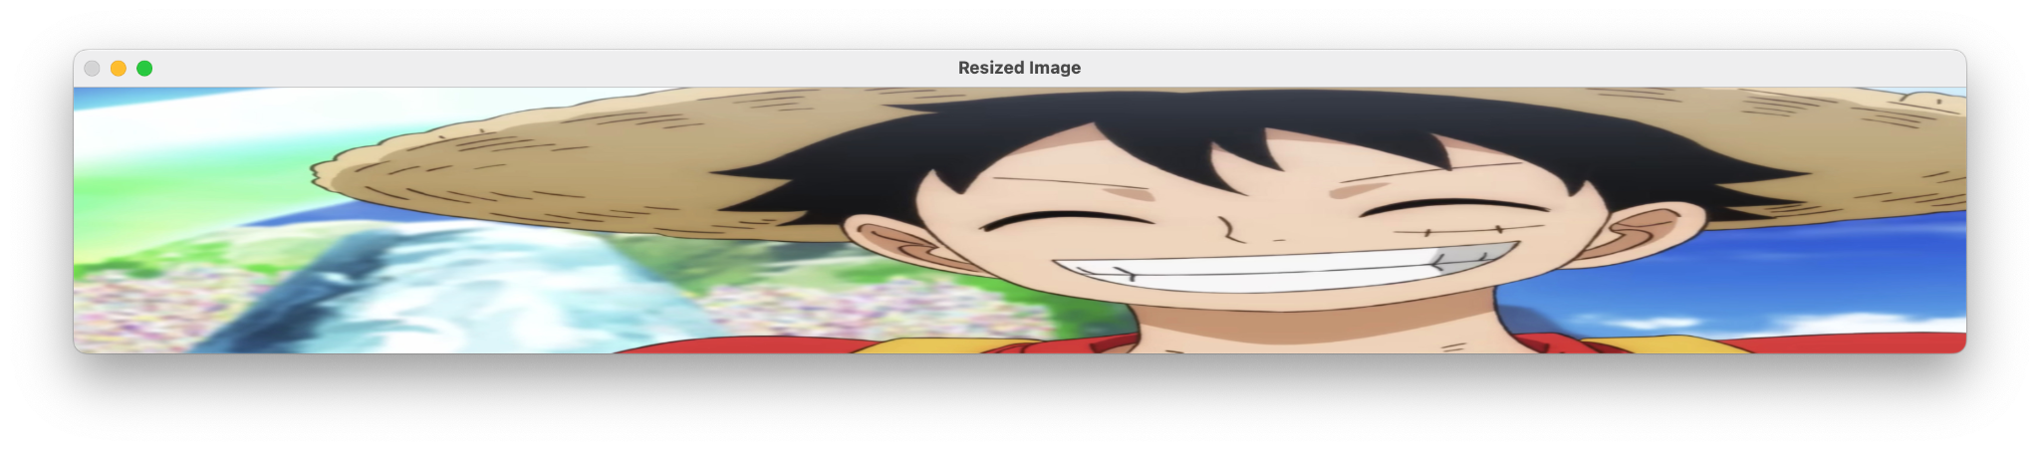

1. If **perspective transformation** is selected, apply the transform with the following homography matrix and use same image size for output image. Paste a sample here.

$H=\left[0.4 -0.4 190 0.15 0.4 100 0 0 1 \right]$

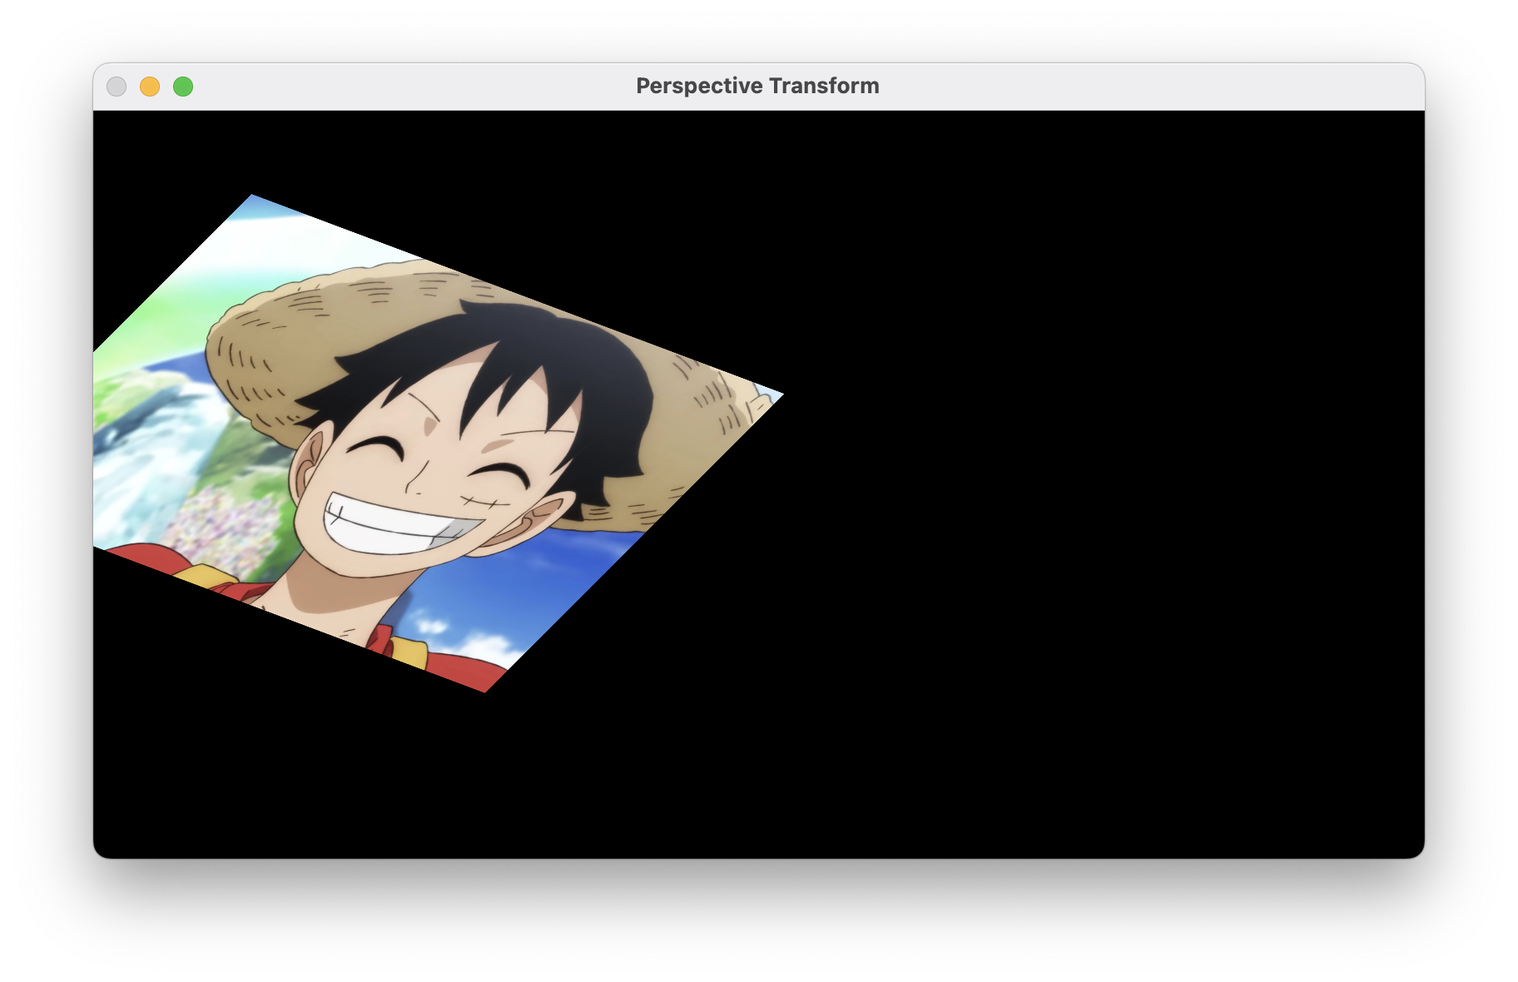

## **Part IV: Noise and Filtering**

Create a program (save as Assignment02_4). Include code to:

1. Open a color image and display. Paste a sample here.



1. Ask the user for a probability value between 0 and 1 and implement the ‘Salt & Pepper Noise’ with the given probability.

To create this noise, note that:

* The noisy image is the same as image except at affected pixels.
* The number of pixels affected by noise is $p×width×height$ of image.
* The location of each affected pixel (row and column) is random within possible row and column values.
* The color of the noise is either black or white.

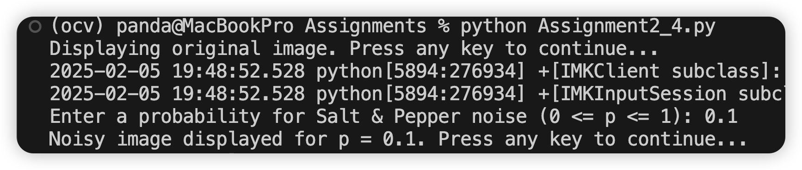

1. Create two noisy images with p = 0.10 and p = 0.20. Paste the results here.

For the following steps, use separable filters where applicable to denoise the noisy images.

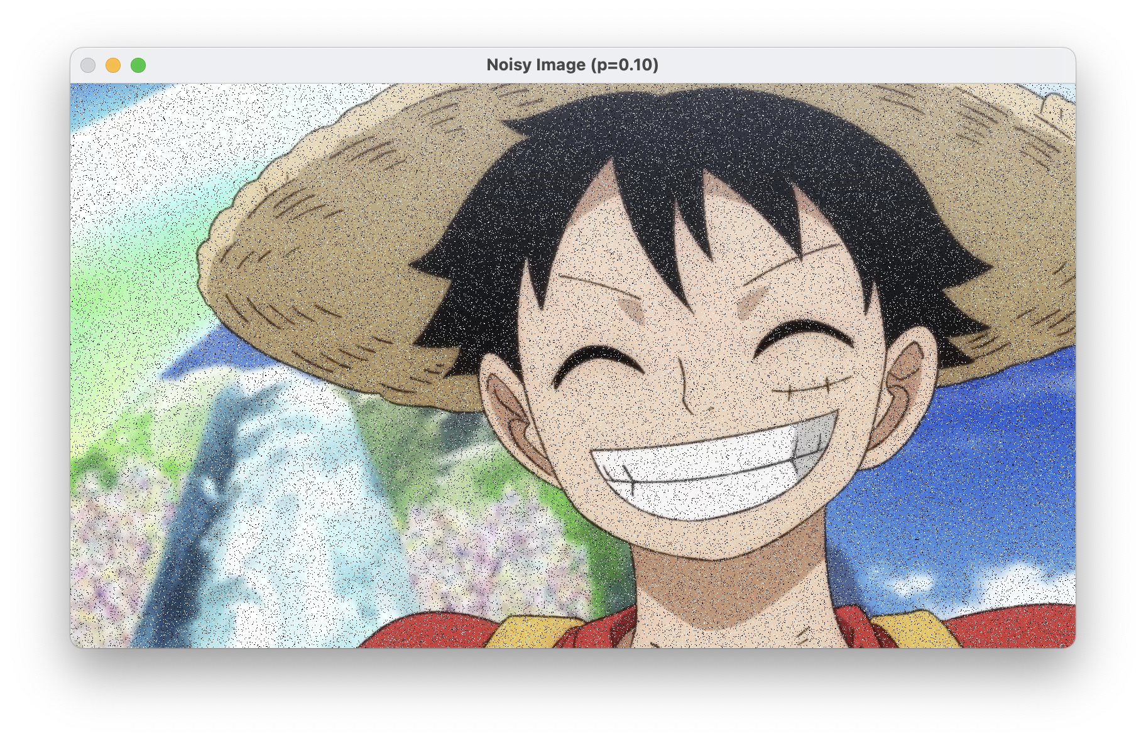

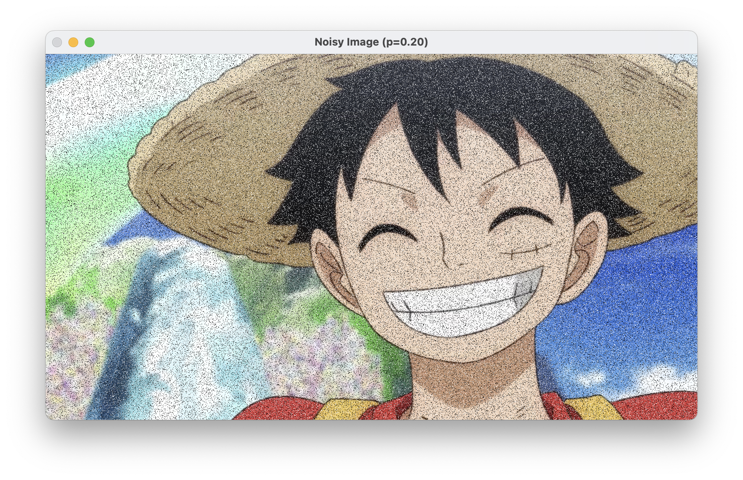

1. Apply a $3×3$ Box Filter. Paste the result here.

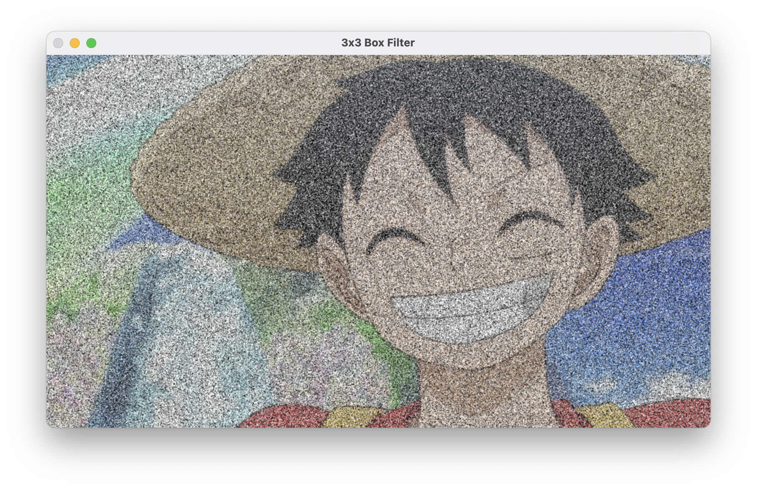

1. Apply a $3×3$ Median Filter. Paste the result here.

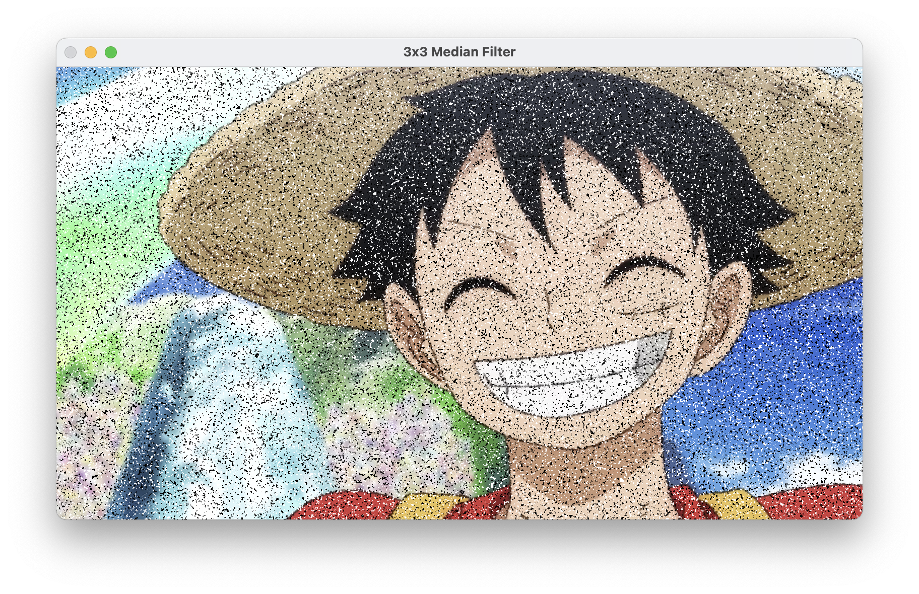

1. Apply a $3×3$ Bilinear Filter. Paste the result here.

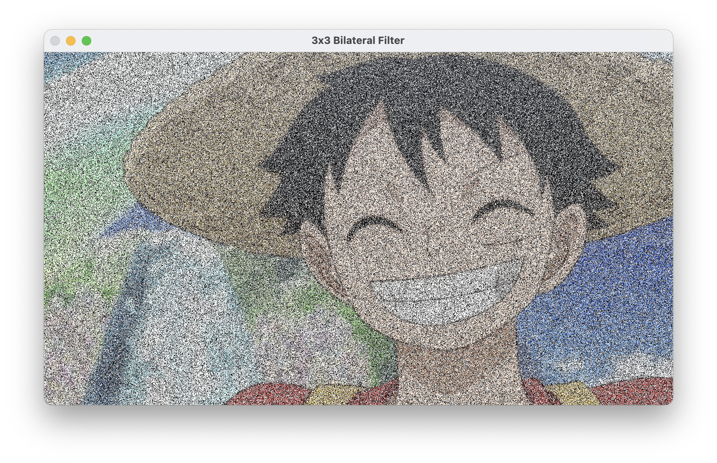

1. Compare the results of the above filters (parts 4, 5, 6). Which filter works better for de-noising? Why is that?

I applied a 0.90 probability of salt and pepper noise to the original image, and based on the resulting images, the median filter does a better job than box or bilateral. It performs better at removing salt and pepper noise. The box filter blurs the entire image uniformly, which can reduce noise but also smear edges and details. The bilateral filter helps preserve edges but is not as effective for isolated salt & pepper dots. However, it is quite good for “Gaussian-like” noise while preserving edges.

1. Try different kernel sizes, for example, $11×11$ and $25×25$. Explain how the kernel size will affect the results.

Larger kernels will remove more noise but also cause more blurring and loss of details. For example, an 11×11 median filter removes more pepper and salt noise, but also removes some finer structures. A 25×25 box filter heavily blurs the image. The entire region becomes an average of a large block.

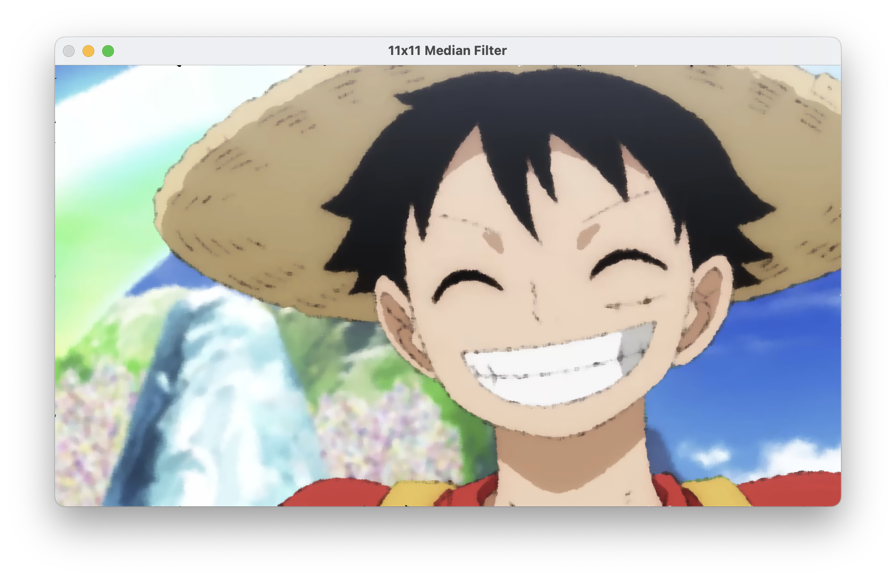

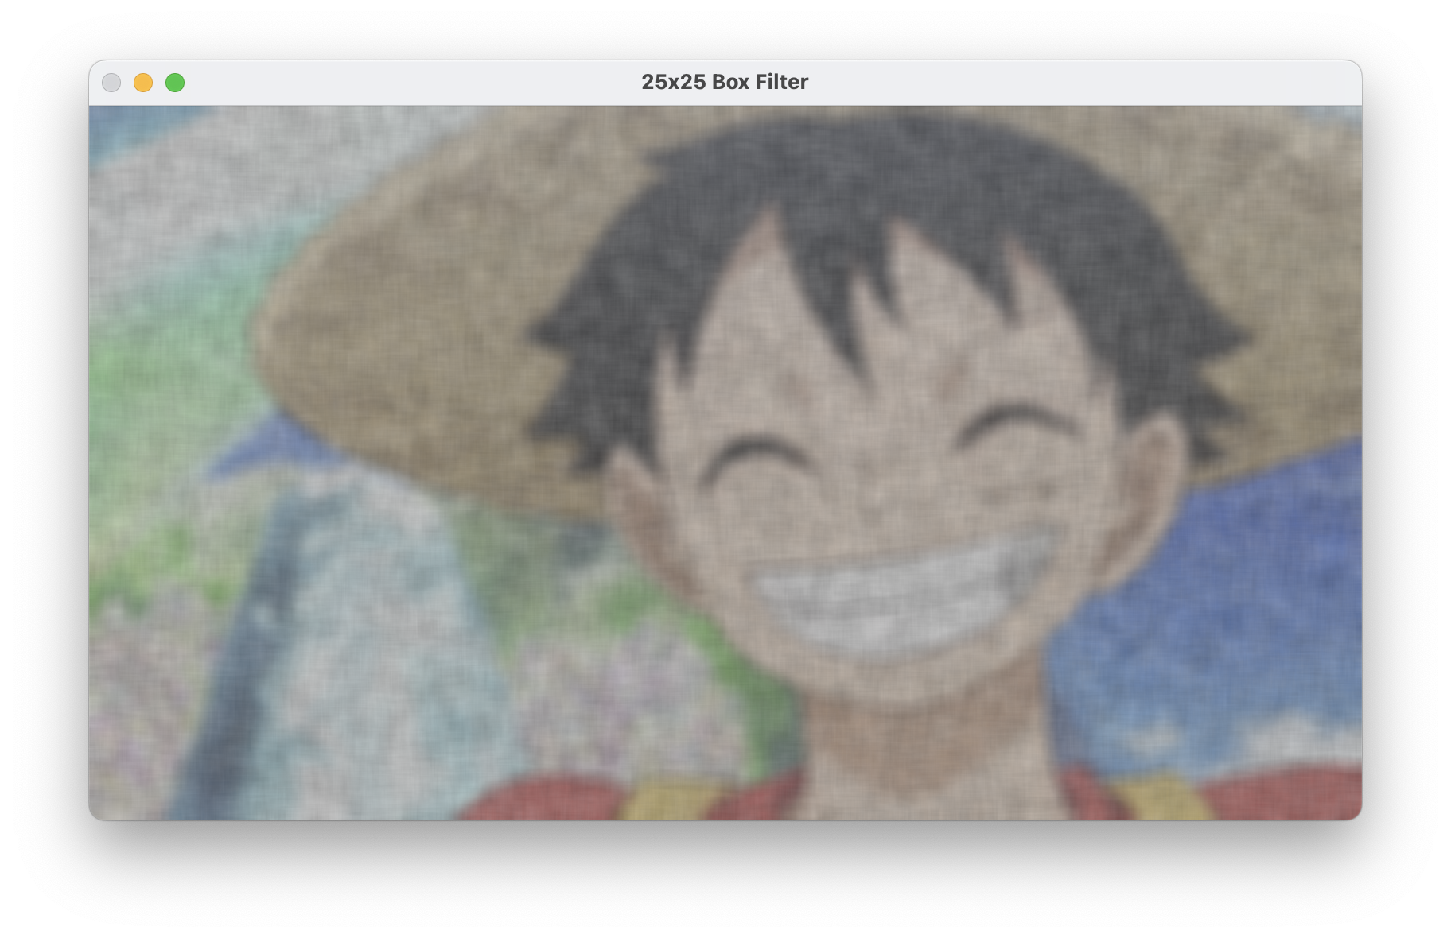

## **Part V: Calculations**

1. In Part IV, select a pixel and output its B, G, and R values, along with the values of its neighbors, before denoising.

Pixel selected: (row, col) = (100, 100)

Pixel(100, 100) -> B=254, G=255, R=253

Neighborhood (BGR values):

(99,99) -> B=254, G=255, R=253

(99,100) -> B=0, G=0, R=0

(99,101) -> B=255, G=255, R=255

(100,99) -> B=254, G=255, R=253

(100,100) -> B=254, G=255, R=253

(100,101) -> B=254, G=255, R=253

(101,99) -> B=254, G=255, R=253

(101,100) -> B=255, G=255, R=255

(101,101) -> B=254, G=255, R=253

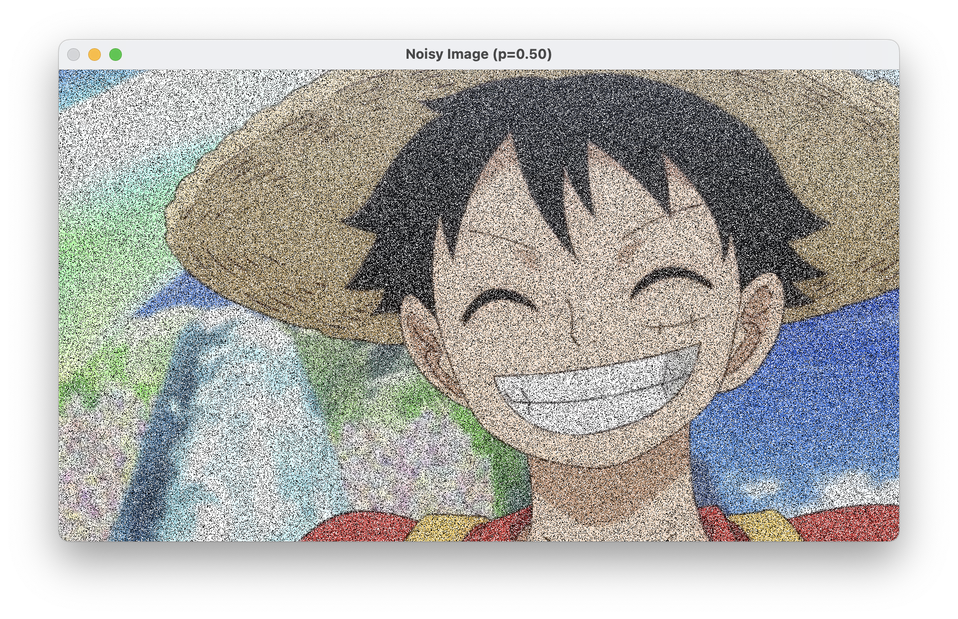

1. Calculate the expected de-noised pixel value. For the B channel, use the Box Filter; for the G channel, use the Median Filter; and for the R channel, use the Bilinear Filter.

# 1) Print the pixel's neighborhood

neighborhood = noisy_img[row-1:row+2, col-1:col+2]

print("Neighborhood BGR values:")

for rr in range(3):

for cc in range(3):

b, g, r_val = neighborhood[rr, cc]

print(f"({row-1+rr},{col-1+cc}) -> B={b}, G={g}, R={r_val}")

print()

# 2) Manual calculation

# B channel (box)

b_vals = [neighborhood[rr, cc, 0] for rr in range(3) for cc in range(3)]

b_box = sum(b_vals)/9.0

# G channel (median)

g_vals = [neighborhood[rr, cc, 1] for rr in range(3) for cc in range(3)]

g_vals.sort()

g_median = g_vals[4]

# R channel (bilinear: average corners)

R_tl = neighborhood[0,0,2]

R_tr = neighborhood[0,2,2]

R_bl = neighborhood[2,0,2]

R_br = neighborhood[2,2,2]

r_bilinear = 0.25*(R_tl + R_tr + R_bl + R_br)

manual_b = int(round(b_box))

manual_g = int(round(g_median))

manual_r = int(round(r_bilinear))

print(f"Manually calculated denoised pixel = (B={manual_b}, G={manual_g}, R={manual_r})")

Output:

Manually calculated denoised pixel = (B=226, G=255, R=62)

1. Output the value of the pixel after the image has been de-noised.

# 3) Officially apply the combined approach to entire image

b_channel, g_channel, r_channel = cv2.split(noisy_img)

B_box = cv2.blur(b_channel, (3,3))

G_median = cv2.medianBlur(g_channel, 3)

R_bilinear = bilinear_filter_r_channel(r_channel)

combined = cv2.merge([B_box, G_median, R_bilinear])

final_pixel = combined[row, col]

print(f"Pixel in final denoised image = (B={final_pixel[0]}, G={final_pixel[1]}, R={final_pixel[2]})")

Output:

Pixel in final denoised image = (B=226, G=255, R=62)

1. Do the output value and the result of your calculation match? Explain.

Yes, the two results match. The reason is that I applied the same filtering logic. I used the exact same formulas in the manual calculation as in the code that generated the officially denoised image. For the B channel (Box Filter), both the manual code and cv2.blur() effectively did the same operation—summing the 3×3 block for the B values and dividing by 9. For the G channel (Median Filter), the manual median calculation is identical to what cv2.medianBlur() does, which is taking the 9 G values in the 3×3 neighborhood, sorting, and picking the 5th. For the R channel (Bilinear Filter), I wrote a custom function bilinear_filter_r_channel() that uses the same corner-average approach as the manual corner-averaging logic (0.25 times each corner). The same rounding technique applied to both methods, so the two methods are guaranteed to match.